主标题：Rtk Tablet
副标题：Y100-RTK Android GNSS RTK tablet
Key features:
MT6789 (2 Arm) ® Cortex-A76 core, operating frequency of 2.2GHz, 6 Arm ® Cortex-A55 core, operating at a frequency of 2.0GHz
Memory :8G+128G Optional:8G+256G
10.1-inch resolution 1200X1920
2G,3G,4G wireless communication,NFC
GPS/QZSS: L1C/A、L2P(W)、L5
BDS: B1I、B2I、B3I、B1C、B2a
Galileo: E1、E5a、E5b
GLONASS: G1、G2

Y100 is an GNSS Rtk Tablet by LQYCIT. 10.1-inch high-definition large screen, 8-core 2.2GHz high-performance CPU, standard configuration: 6G+128G memory, Android 13 system, 4G communication, WIFI, BT, IP67+1-meter drop.
Integrated high-precision GNSS positioning board, built-in RTK algorithm, paired with four arm spiral antenna, supporting centimeter level accuracy. Support BDS, GPS, GALILEQ, GLONASS, QZSS full system GNSS. High precision data collection is applied to various spatial data collection, inspection and patrol work.
Widely used in land, electricity, forestry, environmental protection, highways, railways, ship monitoring, oil and gas pipelines, mining exploration and other operations.
GNSS Rtk Tablet used in a wide range of extreme conditions. Perfect Drop-proof, Waterproof and Dust-proof. One-stop rapid customization services.
an Android GNSS RTK tablet with a sunlight-readable display, ideal for GIS data collection and surveys.
Rtk Tablet-1
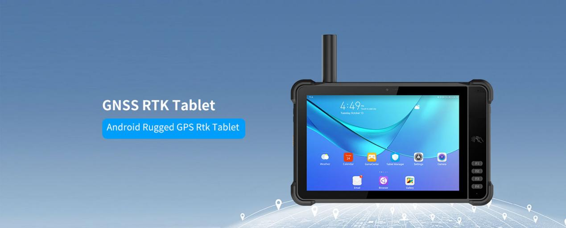
Rtk Tablet-2
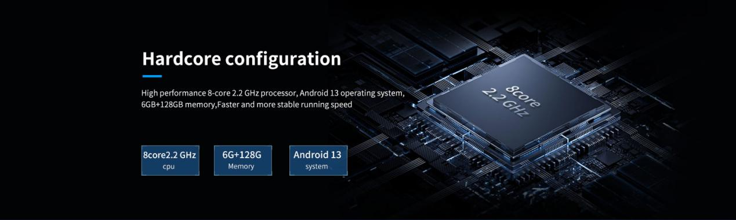
Strong performance hardcore configuration
High performance 8-core 2.2 GHz processor:MT6789 (2 Arm) ® Cortex-A76 core, operating frequency of 2.2GHz, 6 Arm ® Cortex-A55 core, operating at a frequency of 2.0GHz .Android 13 operating system, standard configuration: 6GB+128GB memory, optional: 8GB+128GB,8G+256G. Running faster and more stable.
Rtk Tablet-3
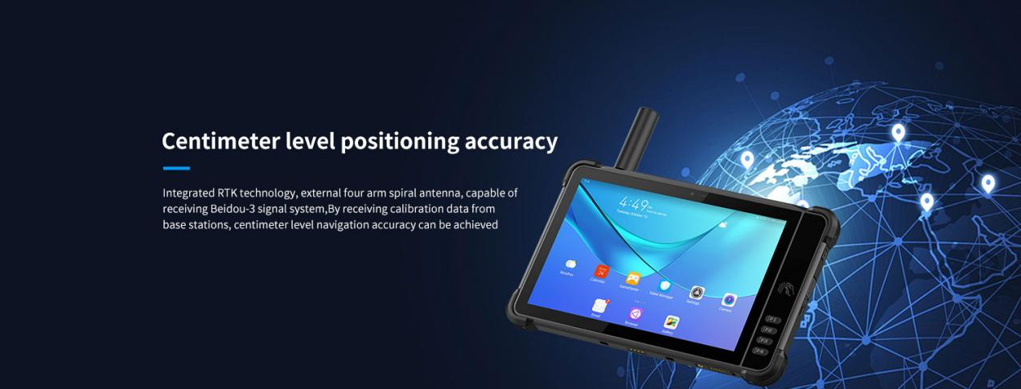
RTK centimeter level positioning accuracy
Y100 Rtk Tablet Integrated high-sensitivity GNSS module, external four arm spiral antenna, achieves centimeter level navigation accuracy by receiving calibration data from base stations. Supports multiple satellite systems such as GPS, GLONASS, Galileo, Beidou, QZSS, and SBAS, providing reliable RTK positioning even in the most challenging environments.
GNSS RTK module options: UM960, UM980, UM982, UBLOX-9N, UBLOX-F9P.
﻿Rtk Tablet-4
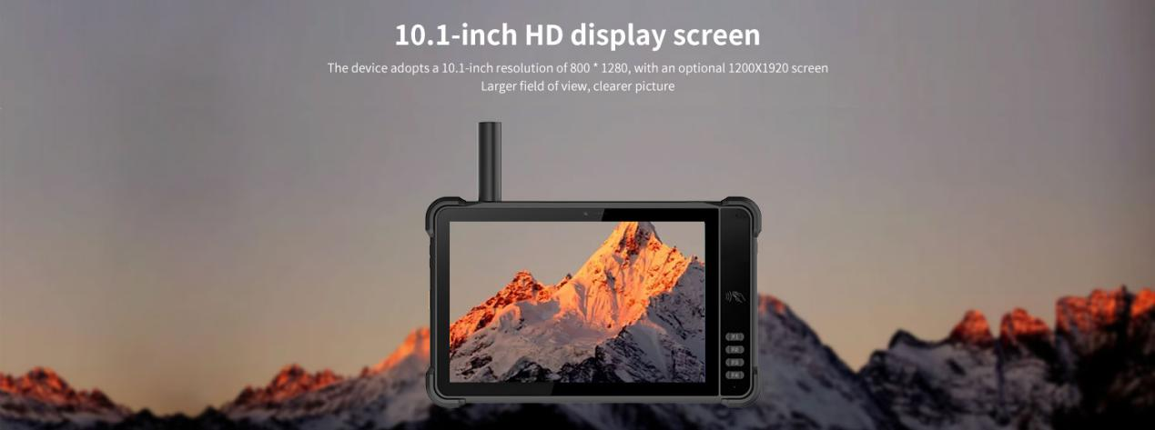

10.1-inch HD display screen
The Rtk Tablet device adopts a 10.1-inch resolution of 1200X1920, for a larger field of view and clearer images.
Rtk Tablet-5
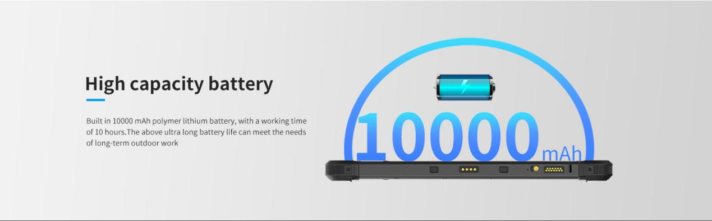
Long lasting endurance of large capacity batteries
Built in 10000 mAh polymer lithium battery, with a working time of over 10 hours and ultra long battery life, can meet the needs of long-term outdoor work.
Type-C 30W PD fast charging
The charging time is 2-3 hours, using the standard power adapter and data cable.
Rtk Tablet-6
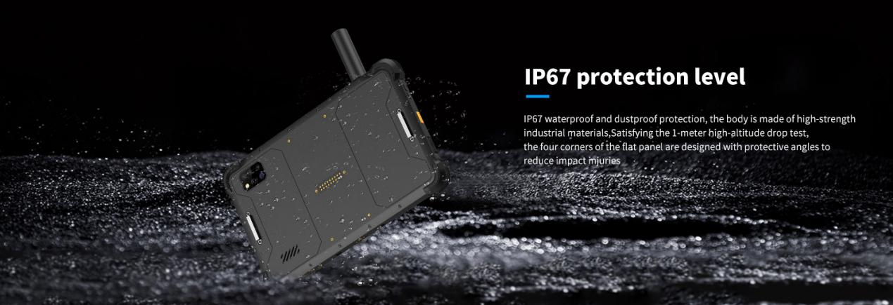
Protection level
IP67 dustproof and waterproof; The body is made of high-strength industrial materials, which are sturdy and durable, and can meet the requirements of a 1-meter high-altitude drop test. The four corners of the tablet are designed with protective angles, effectively reducing impact injuries.
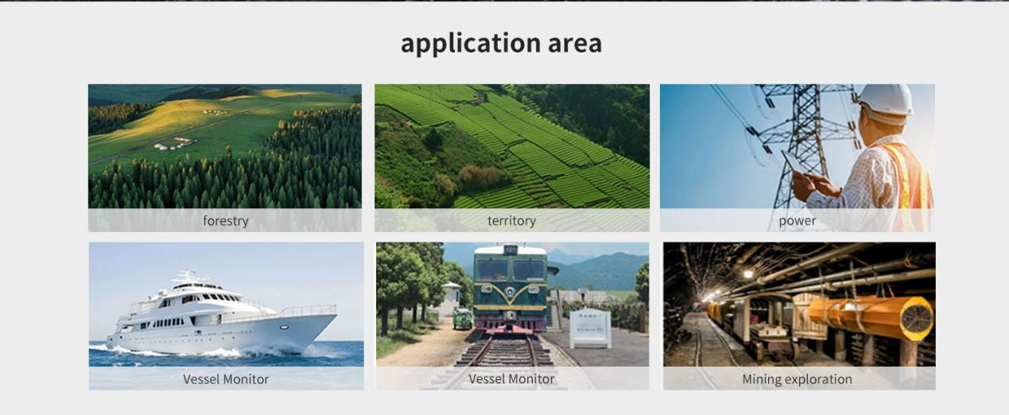

Provide ODM and OEM customized services
We work closely with our partners and can provide various one-stop customized solutions.
Appearance customization: supports customization of product nameplates, product packaging, and promotional materials.
Hardware customization: Supports customization of functional modules and optional hardware functions.
Software customization: supports customization of boot interface, boot program, kernel clipping, and API interface.
Technical support: Provide SDK development kits and application software development technical services.

HARDWARE CUSTOMIZATION
1: Nameplate Logo Customization
2:Packaging Custom Design
﻿
SOFTWARE CUSTOMIZATION
1:Boot Screen Customization
2:System Function Hiding
3:Built-in Customer App
4:Customer App Auto-launch
5:Platform Software Integration
6:Fixed MAC Address
7:Download Prohibition
﻿8:USB Disablement
﻿9:APP Installation and Uninstallation Control
10:Pre-installed APK
﻿11:Camera Control
12:Provide System Signing Files

frequently asked questions
Q: Are you the original manufacturer?

A: Yes, we are the original manufacturer. We have our own brand LQYCIT. All of our products have complete patented ID/MD designs, hardware and software, molds, and assembly are all completed by our own team.

Q: Can you pre install our software?

A: Yes, we can pre install your software.

Q: What is the minimum order quantity?

A: We accept standard product orders starting from one unit. If necessary, we can even customize your logo. For OEM, our sales team will review the detailed requirements and confirm the minimum order quantity.

Q: Can we get free samples?

A: Sorry, we usually do not provide free samples. If the customer confirms the specifications and pricing, they can first order samples for testing and evaluation.

Q: How to place an order and make payment?

A: We accept wire transfers (bank transfers), Alibaba online payments, and Western Union remittances.

Q: What is the warranty period for your products?

A: We offer a 12-month warranty after shipment.

Q: How long is the delivery time?

A: The production delivery cycle is about 3-10 days, depending on the requirements. The delivery time through DHL/UPS/FedEx/TNT is approximately 3-5 working days. For some remote areas, the transportation time may be longer.

Q: How to fix equipment problems?

A: We will provide online technical support to solve problems. For hardware issues, we can ship parts or components for customers to install (if they have technicians), or we can ship them back to us for repairs.

